Well, first of all, good afternoon to everyone reading this. I'm bringing a little guide on how to correct this error so often.

* First open Shaiya Data File Tool by lilprohacker
* Select your data.sah and in the folder called Data, you will find a file called Cash.sdata, you give and give right click to extract.
* 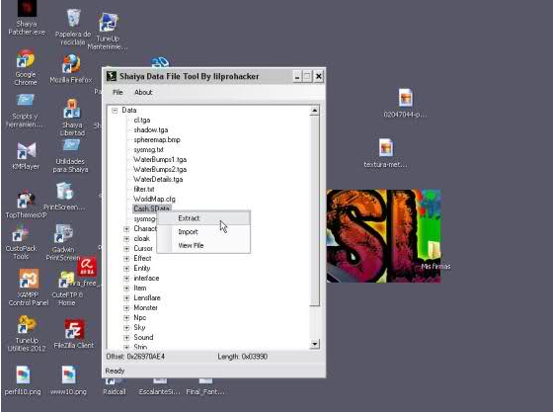Once you've extracted Cash.sdata, open Shstudio.
* 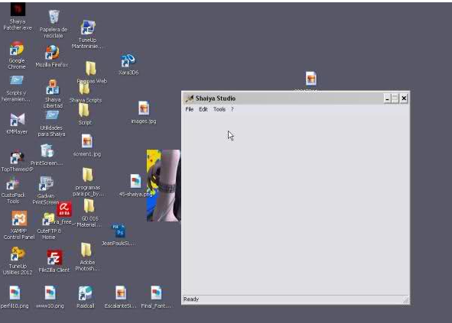Once opened Shstudios, select the file Cash.sdata and open it.
* 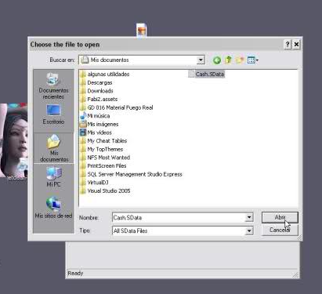
* After selecting the file Cash.sdata you a list, which are your products from the Item Mall
* 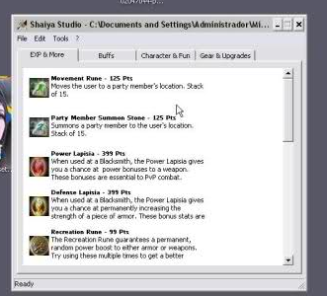
* So if you want to change any item in the list is up to you, in my case this tutorial I will open and keeps it, after you save will have a file called Cash.sql
* 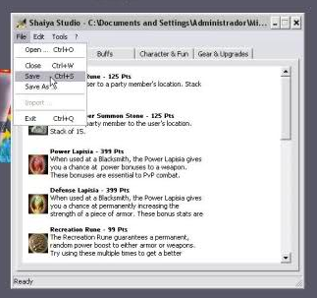
* Then you open that file named Cash.sql said.  
  It will open and you will run.
* 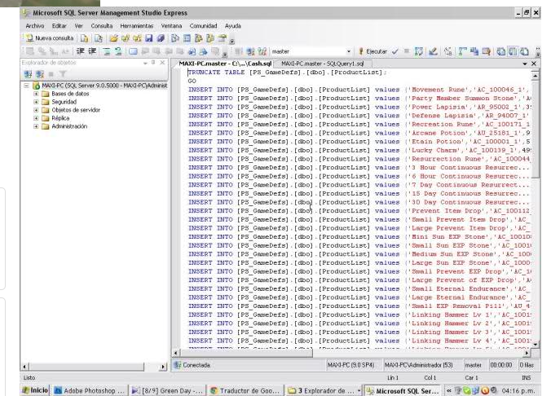
* You press execute, expect to analyze.
* 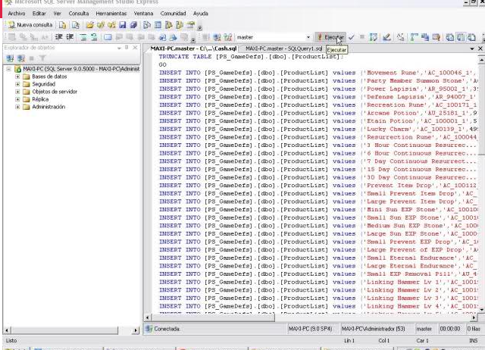
* After all this, run the Cash.sdata, you must restart the services, and work your item mall

Nothing more, I hope they have helped, is the least I can do for you!  
See you later.